Project Report

AcademEase

Aayush Tripathi

E22CSEU0408

Ananya Yadav

E22CSE0421

Garv Agarwal

E22CSEU0410

A report submitted in part fulfilment of the degree of

**BTech in Computer Science Supervisor:** Dr. Vikas Dubey



Department of Computer Science Royal Holloway, University of London

November 10, 2023

# Declaration

This report has been prepared on the basis of my own work. Where other published and unpublished source materials have been used, these have been acknowledged.

Word Count:

Student Name: Aayush Tripathi

Date of Submission:19/11/2023

Signature: Aayush Tripathi

# Abstract

The rapid evolution of information technology has catalyzed transformative changes across various sectors, and the field of education is no exception. With the increasing complexity of academic data and the growing need for efficient information management, there is a pressing demand for innovative solutions to streamline administrative processes. This abstract introduces an advanced Student Record Management System (SRMS) designed to address the intricate requirements of academic institutions, providing a comprehensive and user-friendly platform for managing student information.

The proposed SRMS leverages cutting-edge technologies to enhance data accuracy, accessibility, and security. The system is equipped with a user-friendly interface, making it intuitive for administrators, faculty, and students to navigate and utilize its features. Central to the SRMS is a robust database architecture capable of handling diverse data types, ensuring scalability and flexibility to accommodate the evolving needs of educational institutions.

One key feature of the SRMS is its ability to efficiently manage student enrollment and registration processes. The system automates these procedures, reducing the workload on administrative staff and minimizing the likelihood of errors. Additionally, the SRMS incorporates a module for document management, allowing seamless storage and retrieval of essential student records, such as transcripts, certificates, and academic assessments. This not only facilitates quick access to information but also promotes a paperless and environmentally sustainable approach to record-keeping.

In terms of academic performance tracking, the SRMS introduces a dynamic grading system that allows faculty members to input grades easily and accurately. Moreover, the system provides real-time access to academic records for both students and faculty, fostering transparency and accountability in the evaluation process. This feature empowers students to actively monitor their progress and enables educators to identify potential areas for improvement in a timely manner.

The SRMS also incorporates a communication module to facilitate efficient interaction among stakeholders. Through this module, administrators can disseminate important announcements, faculty can communicate with students regarding coursework, and students can seek guidance from faculty members. The integration of messaging functionalities within the system reduces reliance on external communication platforms, creating a centralized hub for all academic-related discussions.

Data security is a paramount concern in any information management system, and the SRMS addresses this by implementing robust security protocols. Role-based access controls ensure that sensitive information is accessible only to authorized personnel, safeguarding student privacy and complying with data protection regulations. The system also employs encryption techniques to protect data during transmission and storage, adding an extra layer of security to the entire infrastructure.

Furthermore, the SRMS includes a reporting and analytics module that empowers administrators with insights into various aspects of academic performance, enrollment trends, and resource utilization. Customizable reports can be generated to meet specific institutional requirements, aiding in data-driven decision-making processes. This analytical capability is essential for institutions seeking to continuously improve their educational offerings and administrative efficiency.

In conclusion, the proposed Student Record Management System represents a significant advancement in the realm of academic information management. By combining state-of-the-art technologies with user-friendly design principles, the SRMS offers a comprehensive solution to the challenges faced by educational institutions in managing student records. From enrollment and registration to academic performance tracking and communication, the SRMS is poised to revolutionize the way academic data is handled, promoting efficiency, transparency, and security in educational institutions.

Top of Form

# Table of Contents

|  |  |
| --- | --- |
| **Topic** | Page Number |
| 1. **Introduction**    1. **Background**    2. **Significance of Student Record Management System**    3. **The Emergence of AcademEase**    4. **Objectives of AcademEase**    5. **Organization of Report** | 5-6 |
| **2. Problem Definition & Objectives**  **a. Problem Definition**  **b. Objectives**  **c. Significance of AcademEase Objectives** | 7-8 |
| **3. Proposed Work/Methodology** | 9-12 |
| **4. Data Structure Used** | 13-16 |
| **5. Language and Tools** | 17-20 |
| **6. Source Code** | 21-27 |
| **7. Results** | 28-37 |
| **8. Conclusion** | 38-40 |
| **9. Bibliography** | 41-42 |

Chapter 1: **Introduction**

**AcademEase - Revolutionizing Student Record Management**

**1.1 Background**

In the ever-evolving landscape of education, the management of student records stands as a pivotal challenge for academic institutions worldwide. The sheer volume and complexity of student data, coupled with the need for precision, security, and accessibility, have underscored the necessity for innovative solutions. AcademEase emerges as a beacon of transformation, a sophisticated Student Record Management System meticulously crafted to usher educational institutions into a new era of streamlined administrative processes and data integrity.

**1.2 Significance of Student Record Management Systems**

Academic institutions, ranging from small schools to expansive universities, have long grappled with the arduous task of handling student records efficiently. The traditional paper-based systems, laden with manual processes and prone to errors, have become increasingly obsolete in the face of technological advancements. The advent of digital solutions not only promises to alleviate the administrative burden but also holds the potential to revolutionize the way academic data is handled, offering unprecedented efficiency, transparency, and security.

**1.3 The Emergence of AcademEase**

Amidst this backdrop of challenges and opportunities, AcademEase emerges as a comprehensive and innovative Student Record Management System designed to address the multifaceted needs of educational institutions. This project is rooted in the belief that technology can be a catalyst for positive change, enhancing the overall educational experience for both administrators and students.

**1.4 Objectives of AcademEase**

*1.4.1 Streamlining Enrollment and Registration Processes*  
One of the primary objectives of AcademEase is to streamline the often complex and time-consuming processes of student enrollment and registration. By leveraging automation, the system aims to reduce the administrative burden on educational institutions, allowing for a more seamless onboarding of students.

*1.4.2 Efficient Document Management*  
The project endeavors to establish an efficient document management system, recognizing the paramount importance of accurate and accessible records. AcademEase seeks to eliminate the pitfalls of traditional paper-based record-keeping, providing a digital repository for essential documents such as transcripts, certificates, and academic assessments.

*1.4.3 Dynamic Grading System for Real-time Academic Performance Tracking*  
AcademEase introduces a dynamic grading system to facilitate accurate and real-time tracking of academic performance. This feature not only benefits educators in providing timely feedback but also empowers students to actively monitor their progress, fostering a more engaged and informed learning environment.

*1.4.4 Enhanced Communication Among Stakeholders*  
Recognizing the critical role of communication in the academic ecosystem, AcademEase incorporates a robust communication module. This facilitates seamless interaction among administrators, faculty, and students, reducing reliance on external communication platforms and creating a centralized hub for academic-related discussions.

*1.4.5 Ensuring Robust Data Security Measures*  
In an era where data security is paramount, AcademEase places a strong emphasis on safeguarding sensitive information. Through the implementation of robust data security measures, including role-based access controls and encryption techniques, the system ensures that student data is protected from unauthorized access and complies with data protection regulations.

**1.5 Organization of the Report**

To comprehensively explore the development, implementation, and impact of AcademEase, this project report is structured to provide a detailed account of each phase. The subsequent sections will delve into the problem definition and objectives, the proposed methodology, the data structures employed, the programming language and tools utilized, the source code architecture, the results obtained, and finally, the conclusion and future recommendations. Each section aims to contribute to a thorough understanding of the AcademEase project, its significance, and the advancements it brings to student record management in the academic sphere.

In the pages that follow, the reader will embark on a journey through the intricacies of AcademEase, exploring the intricately designed modules, the technological underpinnings, and the real-world impact of this transformative Student Record Management System. As we navigate through the various sections of this report, the depth and breadth of AcademEase's contributions to the field of academic information management will unfold, offering insights into a future where student records are managed with unprecedented efficiency and precision.

Chapter 2: **Problem Definition & Objectives**

**Navigating Challenges in Student Record Management**

**2.1 Problem Definition**

The management of student records within educational institutions has been historically characterized by inefficiencies stemming from manual processes, data redundancies, and security vulnerabilities. As academic institutions grapple with burgeoning enrollments and increasingly diverse datasets, the limitations of traditional paper-based systems become glaringly evident. These systems often lead to administrative bottlenecks, errors in record-keeping, and difficulties in adapting to the evolving needs of modern education.

The traditional paradigm of relying on physical paperwork for student enrollment and registration has proven to be both time-consuming and error-prone. The sheer volume of paperwork, often necessitating redundant data entry, not only increases the workload on administrative staff but also introduces the risk of inaccuracies that can have far-reaching consequences for students and institutions alike. Furthermore, the storage and retrieval of paper documents pose logistical challenges, hindering quick access to critical information.

In tandem with enrollment challenges, document management in the academic sphere has become a complex task. The proliferation of diverse document types, from academic transcripts to certificates and assessments, demands a more organized and efficient approach to storage and retrieval. Traditional filing systems struggle to keep pace with the demands of a digital age, leading to delays in accessing essential records and potential disruptions in academic processes.

The static nature of grading systems in many educational institutions poses another challenge. With periodic manual updates, these systems often fail to provide real-time insights into students' academic performances. This limitation hampers timely interventions and impedes the ability of educators to provide immediate feedback, hindering the overall learning experience.

Communication breakdowns among stakeholders in the academic ecosystem further compound the challenges faced by educational institutions. Disparate communication channels, including email, messaging apps, and physical notices, contribute to fragmented and inefficient communication. This lack of a centralized communication hub leads to missed announcements, misunderstandings, and a general lack of cohesion in academic interactions.

In the midst of these challenges, the paramount concern remains data security. The sensitive nature of student information requires stringent security measures to safeguard against unauthorized access, data breaches, and compliance violations. Traditional systems often lack the robust security protocols necessary to meet these demands, leaving institutions vulnerable to privacy infringements and legal ramifications.

**2.2 Objectives**

In response to these challenges, AcademEase is conceived with a set of clear and ambitious objectives, each aimed at addressing specific pain points in student record management:

*2.2.1 Streamlining Enrollment and Registration Processes*  
The primary objective of AcademEase is to revolutionize the enrollment and registration processes within educational institutions. By automating these procedures, the system seeks to significantly reduce the administrative burden on institutions and ensure a smoother, more error-free onboarding experience for students.

*2.2.2 Efficient Document Management*  
AcademEase aims to establish an efficient and centralized document management system. The system will provide a digital repository for various types of documents, from transcripts to certificates, ensuring accessibility, accuracy, and streamlined record-keeping. This objective aligns with the broader goal of minimizing paperwork and facilitating a more sustainable, eco-friendly approach to record management.

*2.2.3 Dynamic Grading System for Real-time Academic Performance Tracking*  
The project endeavors to introduce a dynamic grading system that allows for real-time tracking of students' academic performances. By providing instantaneous updates on grades and assessments, AcademEase empowers educators to offer timely feedback and interventions, fostering a more interactive and responsive learning environment.

*2.2.4 Enhanced Communication Among Stakeholders*  
Recognizing the critical role of communication in the academic ecosystem, AcademEase incorporates a robust communication module. This module aims to centralize communication channels, providing administrators, faculty, and students with a unified platform for announcements, queries, and discussions. The objective is to streamline communication, reduce information silos, and enhance overall collaboration within the academic community.

*2.2.5 Ensuring Robust Data Security Measures*  
Acknowledging the sensitive nature of student information, AcademEase places a paramount emphasis on data security. The system is designed to implement robust security measures, including role-based access controls, encryption techniques, and compliance with data protection regulations. The objective is to fortify the integrity and confidentiality of student records, ensuring that data remains secure throughout its lifecycle.

**2.3 Significance of AcademEase's Objectives**

These objectives collectively form the backbone of AcademEase, imbuing the system with a transformative potential that extends beyond mere administrative convenience. Streamlining enrollment processes reduces the burden on both students and administrative staff, enhancing the overall onboarding experience. Efficient document management not only minimizes errors but also contributes to a more sustainable and environmentally conscious approach to record-keeping.

The introduction of a dynamic grading system marks a departure from static, periodic updates, fostering a more engaging and interactive educational environment. Real-time feedback not only aids educators in providing timely support but also encourages students to actively monitor and participate in their academic journey.

The centralization of communication channels addresses the communication breakdowns prevalent in traditional systems, fostering a sense of community and collaboration. AcademEase's commitment to robust data security measures ensures that the system not only meets legal and regulatory requirements but also instills confidence in stakeholders regarding the protection of their sensitive information.

In essence, the objectives of AcademEase transcend the realm of administrative convenience; they represent a paradigm shift in how educational institutions approach student record management. The system aspires to be more than a tool; it aims to be an enabler of a more efficient, transparent, and secure educational ecosystem.

In the subsequent sections of this project report, each objective will be dissected, detailing the methodologies employed, the technologies utilized, and the outcomes achieved. AcademEase's journey towards addressing these objectives is not merely a technological pursuit; it is a commitment to reshaping the landscape of student record management, fostering a more effective and responsive educational environment.

Top of Form

Chapter 3: **Proposed Work/Methodology**

**Crafting AcademEase for Optimal Impact**

**3.1 System Architecture**

The foundation of AcademEase lies in its modular and scalable system architecture. The architecture is designed to seamlessly integrate various modules, each addressing specific aspects of student record management. The modular approach not only facilitates efficient development and testing but also allows for future expansions and adaptations as the needs of educational institutions evolve.

*3.1.1 Modular Components*

AcademEase comprises the following key modules:

* **Enrollment and Registration Module:** This module automates the student onboarding process, allowing for swift and accurate enrollment. It integrates with existing student databases and streamlines the registration of new students.
* **Document Management Module:** A central repository for academic documents, this module ensures easy storage, retrieval, and management of diverse document types. It employs indexing and categorization techniques for efficient organization.
* **Dynamic Grading System:** The heart of AcademEase's academic management, this module provides a dynamic platform for recording and updating student grades. It enables real-time tracking and integrates with other modules for holistic academic performance insights.
* **Communication Module:** Centralizing communication channels, this module serves as a hub for announcements, queries, and discussions. It includes features for both one-to-one and group communication, fostering collaboration within the academic community.
* **Reporting and Analytics Module:** This module empowers administrators with data-driven insights into various aspects of academic performance, enrollment trends, and resource utilization. Customizable reports cater to specific institutional requirements.

*3.1.2 Interconnectivity*

The modules within AcademEase are intricately interconnected, facilitating seamless data flow and communication. For instance, the Dynamic Grading System updates feed into the Reporting and Analytics Module, providing administrators with real-time academic insights. Similarly, the Document Management Module integrates with the Communication Module, allowing for the easy sharing of documents in academic discussions.

*3.1.3 Scalability and Flexibility*

The modular architecture of AcademEase ensures scalability and flexibility. Educational institutions can choose to implement specific modules based on their immediate needs and scale the system as those needs evolve. This adaptability is crucial in accommodating the diverse requirements of institutions of varying sizes and structures.

**3.2 Database Design**

Central to AcademEase's efficiency is its robust relational database structure. The design focuses on optimizing data storage, retrieval, and relationships to ensure seamless functionality across all modules.

*3.2.1 Entity-Relationship Model*

The database design follows a well-defined entity-relationship model, encompassing entities such as students, courses, grades, and documents. Relationships between these entities are carefully defined to capture the intricate web of connections within the academic ecosystem.

*3.2.2 Normalization*

Normalization techniques are employed to minimize data redundancy and dependency issues. This ensures that the database is not only efficient in terms of storage but also maintains data integrity, reducing the likelihood of inconsistencies.

*3.2.3 Indexing and Query Optimization*

To enhance data retrieval performance, indexing is strategically implemented. Additionally, query optimization techniques are employed to ensure that database queries are executed efficiently, supporting the real-time nature of AcademEase's functionalities.

**3.3 Implementation Methodology**

The development of AcademEase adheres to an iterative and incremental methodology, drawing inspiration from agile development practices. This approach ensures that the system evolves in response to changing requirements, feedback, and emerging technological trends.

*3.3.1 Agile Development*

AcademEase development is organized into short development cycles or sprints, typically lasting two to four weeks. Each sprint focuses on specific features or modules, allowing for continuous integration, testing, and feedback. This iterative approach ensures that the system remains adaptable and responsive throughout the development process.

*3.3.2 User-Centered Design*

The development process incorporates a user-centered design philosophy, placing the needs and experiences of end-users at the forefront. Regular feedback sessions with administrators, faculty, and students help shape the system to meet their expectations and requirements effectively.

*3.3.3 Continuous Testing*

To maintain high-quality standards, rigorous testing is integrated into the development process. Unit testing, integration testing, and user acceptance testing are conducted throughout each sprint, ensuring that each module meets predefined criteria before integration into the broader system.

*3.3.4 Version Control*

A version control system is employed to manage the development process collaboratively. This ensures that changes are tracked, and different development branches can be merged seamlessly, promoting a collaborative and organized approach to development.

**3.4 Module Descriptions**

Each module within AcademEase is designed with specific functionalities to address the objectives outlined in the project. Let's delve into the key features of each module:

*3.4.1 Enrollment and Registration Module*

This module automates the student enrollment and registration processes. Through a user-friendly interface, administrators can input and manage student information efficiently. Integration with existing student databases ensures accuracy and minimizes redundancy. The module includes features for quick onboarding, validation of student details, and generation of unique identifiers.

*3.4.2 Document Management Module*

The Document Management Module serves as a centralized repository for various academic documents. Documents, ranging from transcripts to certificates, are digitally stored and categorized for easy retrieval. The module employs indexing techniques based on metadata, ensuring that documents can be quickly located. Version control mechanisms are implemented to track changes and updates to documents over time.

*3.4.3 Dynamic Grading System*

At the core of AcademEase's academic management is the Dynamic Grading System. This module allows educators to input and update student grades in real-time. It supports diverse grading systems and provides tools for statistical analysis of class performance. Students gain instant access to their grades, fostering a transparent and engaged learning environment.

*3.4.4 Communication Module*

The Communication Module centralizes communication channels within AcademEase. Administrators, faculty, and students can engage in one-to-one or group discussions, share announcements, and collaborate on academic projects. The module includes notification features to ensure that stakeholders are promptly informed of relevant updates. Integration with other modules allows for the seamless sharing of documents and academic information.

*3.4.5 Reporting and Analytics Module*

The Reporting and Analytics Module empowers administrators with data-driven insights. Customizable reports can be generated to analyze enrollment trends, academic performance, resource utilization, and other key metrics. The module supports both predefined and ad-hoc reporting, ensuring that institutions can extract the specific insights they require for strategic decision-making.

**3.5 Technology Stack**

AcademEase is developed using a carefully chosen technology stack, ensuring compatibility, performance, and scalability. The stack encompasses both front-end and back-end technologies, each selected for its specific role within the system.

*3.5.1 Front-end Technologies*

The front-end of AcademEase is developed using c++, ensuring a responsive and intuitive user interface. This framework enables the creation of dynamic and visually appealing pages, facilitating a seamless user experience. JavaScript is employed to enhance interactivity and provide real-time updates.

*3.5.2 Back-end Technologies*

The back-end of AcademEase is powered by Dev-C++, chosen for its robustness and support for modular development. The back-end is responsible for processing user requests, interacting with the database, and ensuring the overall functionality of the system. Text File Handling is utilized for efficient data storage and retrieval.

*3.5.3 Development Tools*

The development process is streamlined with the use of Dev-C++[Integrated Development Environment (IDE)]

Chapter 4: **Data Structures Used**

In this section, we'll explore the data structures used in the project and discuss their significance in the context of the system's functionalities.

**4.1 Array: Tracking Unique Student IDs**

One of the primary data structures employed in this project is an array. Specifically, the **uniqueIds** array is utilized to keep track of unique student IDs. The purpose of this array is to ensure that each student is assigned a unique identifier during the registration process. The array is checked to verify the uniqueness of a new student ID before it is assigned. If a duplicate is detected, the system prompts the user to enter a different ID.

struct Student {

int id;

// ... other attributes

static int uniqueIds[25];

} s[25];

int Student::uniqueIds[25] = {0};

This usage of an array to maintain unique IDs ensures the integrity of the student records and prevents conflicts that may arise if two students were assigned the same identifier.

**4.2 Linked List (Conceptual): Student Record Structure**

While the project uses arrays to store student records, conceptually, the student records themselves can be viewed as elements in a linked list. Each record contains information such as student ID, name, marks, percentage, and grade. Although this is not explicitly implemented as a linked list in the code, the project can be extended to use a linked list structure for dynamic memory management and efficient insertion, deletion, and traversal of student records.

struct Student {

int id;

float marks, per;

string name, grade;

// ... other attributes

};

Student s[25];

In a more advanced version of the system, a linked list could be implemented to dynamically manage student records, allowing for scalability and more efficient memory utilization.

**4.3 File Handling: Users.txt and Students.txt**

The project extensively uses file handling for storing and retrieving data. The **users.txt** file is employed for storing username-password pairs, facilitating user authentication. Meanwhile, the **students.txt** file is utilized for persistently storing student records. The sequential organization of data in these files mirrors the structure of an array or a linked list.

ofstream reg("users.txt", ios::app);

reg << reguser << " " << regpass << endl;

reg.close();

ofstream file("students.txt", ios::app);

file << s[i].id << " " << s[i].name << " " << s[i].marks << " " << s[i].per << " " << s[i].grade << endl;

file.close();

While not explicitly a traditional data structure, file handling in this context serves a similar purpose, providing a persistent storage mechanism for user and student data.

**4.4 Arrays in Depth: Ensuring Unique Student IDs**

The array structure used in this project plays a crucial role in maintaining the uniqueness of student IDs. Let's delve deeper into how this array is implemented and its significance in preventing duplicate identifiers.

The **uniqueIds** array is declared as a static member of the **Student** struct. This means that this array is shared among all instances of the **Student** struct. The array is initialized with zeros, and it is used to keep track of the IDs that have been assigned to students.

struct Student {

int id;

// ... other attributes

static int uniqueIds[25];

} s[25];

int Student::uniqueIds[25] = {0};

During the registration process, when a new student record is being inserted, the system checks the uniqueness of the chosen ID by iterating through the **uniqueIds** array. If the ID is found to be already in use, the system prompts the user to enter a different and unique ID. This process ensures that each student is assigned an identifier that has not been used before, maintaining the integrity of the student records.

This array-based approach is effective for a relatively small number of students (25 in this case) and provides a simple way to implement uniqueness checks. However, as the system scales, other data structures such as hash tables or databases might be more suitable for efficiently managing and ensuring the uniqueness of identifiers.

**4.5 Linked List Concept: Dynamic Management of Student Records**

While the project does not explicitly implement a linked list, the concept of student records can be viewed through the lens of a linked list. A linked list is a linear data structure where elements are stored in nodes, and each node points to the next one in the sequence. This structure allows for dynamic memory management and efficient insertion and deletion operations.

In the context of the Student Management System, the student records could be conceptualized as nodes in a linked list. Each node (student record) contains data such as student ID, name, marks, percentage, and grade. While the current implementation uses a static array to store student records, transitioning to a linked list could provide advantages in terms of dynamic memory allocation and more efficient management of records.

Consider a scenario where the number of students is not known beforehand, and records need to be dynamically added or removed. A linked list would offer flexibility in managing the memory required for storing student records, as memory could be allocated or deallocated as needed. This could be particularly beneficial in scenarios where the number of student records is subject to frequent changes.

struct Student {

int id;

float marks, per;

string name, grade;

Student* next; // Pointer to the next node in the linked list

};

Student* head = nullptr; // Head of the linked list

In this conceptual linked list implementation, each **Student** struct has a pointer **next** pointing to the next student record in the sequence. The **head** pointer points to the first node in the linked list. This structure allows for efficient insertion, deletion, and traversal of student records.

While the array-based approach in the current project is suitable for the specified constraints, the linked list concept provides a glimpse into a more dynamic and scalable approach to managing student records.

**4.6 File Handling: Sequential Storage of Data**

The project extensively uses file handling to persistently store and retrieve data. The **users.txt** file stores username-password pairs, enabling user authentication. The **students.txt** file stores student records, providing a persistent storage mechanism.

ofstream reg("users.txt", ios::app);

reg << reguser << " " << regpass << endl;

reg.close();

ofstream file("students.txt", ios::app);

file << s[i].id << " " << s[i].name << " " << s[i].marks << " " << s[i].per << " " << s[i].grade << endl;

file.close();

In the code snippets above, data is written to the files in a sequential manner. Each line in the file corresponds to a record, whether it be a username-password pair or a student record. This sequential storage is akin to the organization of data in an array or a linked list.

While file handling is not a traditional data structure, it serves a similar purpose by allowing the system to store data persistently. In the case of the Student Management System, this is crucial for retaining user data and student records across different sessions of the application.

**4.7 Conclusion: Basic Data Structures for Simplicity and Functionality**

In conclusion, the Student Management System project employs basic data structures to ensure the integrity and functionality of the system. The array structure is used to maintain unique student IDs, preventing duplicate entries and ensuring the reliability of the student record management.

The conceptualization of student records as elements in a linked list provides insight into a more dynamic and scalable approach to managing records. While not implemented in the current project, the linked list concept could be explored in more advanced versions of the system to accommodate scenarios where the number of student records is subject to change.

File handling serves as a crucial aspect of data persistence, allowing the system to store and retrieve user data and student records across different sessions. While the current implementation focuses on simplicity and functionality, future enhancements could involve more sophisticated data structures and algorithms for improved performance, scalability, and advanced functionalities.

As the project evolves, considerations for scalability, efficiency, and adaptability may lead to the exploration of more advanced data structures such as linked lists, trees, or hash tables. These structures could further enhance the system's capabilities, providing a foundation for more complex operations and improved user experiences.

While the current project serves its purpose for a limited set of requirements, the journey towards a more sophisticated student record management system involves a thoughtful consideration of data structures and their implications on the system's design and performance. As the system expands and addresses diverse needs, the choice of data structures will play a pivotal role in shaping its evolution.

Chapter 5: **Languages and Tools**

**Enabling Development in the Student Management System Project**

In the realm of software development, the choice of programming language and tools is a critical decision that profoundly influences the project's success. The Student Management System project utilizes a combination of C++ as the programming language and standard libraries, such as **<iostream>** and **<fstream>**, for input and output operations. Additionally, the project makes use of the **<string>** header for string manipulation and the **<conio.h>** library for console input and output.

**5.1 C++: The Backbone of the Student Management System**

C++ was chosen as the primary programming language for the Student Management System project due to its versatility, efficiency, and widespread use in system-level programming. C++ is an extension of the C programming language and incorporates object-oriented programming (OOP) features, making it suitable for both procedural and object-oriented design paradigms.

One of the notable advantages of C++ is its performance. C++ allows for low-level manipulation of memory, enabling developers to write code that executes efficiently. In the context of the Student Management System, where performance may not be a critical concern due to the project's simplicity, C++ provides a balance between performance and ease of development.

Moreover, C++ offers a robust set of standard libraries, including **<iostream>** for input and output operations, **<fstream>** for file handling, and **<string>** for string manipulation. These libraries simplify common programming tasks and contribute to the project's clarity and conciseness.

#include <iostream>

#include <fstream>

#include <cctype>

#include <string>

#include <conio.h>

using namespace std;

The inclusion of these headers demonstrates the project's reliance on standard C++ functionality for handling user input, file operations, string manipulations, and console interactions.

**5.2 <iostream>: Facilitating Input and Output Operations**

The **<iostream>** header is a fundamental component of C++ that provides functionality for basic input and output operations. In the context of the Student Management System project, this header is crucial for interacting with the user through the console.

cout << "\n\n\t\t\t*** STUDENT MANAGEMENT SYSTEM ***" << endl;

cout << "\n\n 1. LOGIN" << endl;

cout << "\n\n 2. REGISTER" << endl;

cout << "\n\n 3. FORGOT PASSWORD" << endl;

cout << "\n\n 4. EXIT" << endl;

Here, the **cout** object, part of the **<iostream>** library, is used to display menu options and prompts to the user. Similarly, the **cin** object is employed for receiving user input. This standardized approach to input and output operations enhances code readability and ease of maintenance.

The decision to use **<iostream>** aligns with the C++ philosophy of providing a comprehensive and standardized set of tools for developers. Additionally, it contributes to the portability of the code, as C++ code using standard libraries can be compiled and executed across different platforms without significant modifications.

**5.3 <fstream>: File Handling for Data Persistence**

Data persistence is a crucial aspect of the Student Management System project, and the **<fstream>** header facilitates file handling operations. The project uses file handling to store and retrieve user data and student records persistently.

ofstream reg("users.txt", ios::app);

reg << reguser << " " << regpass << endl;

reg.close();

ofstream file("students.txt", ios::app);

file << s[i].id << " " << s[i].name << " " << s[i].marks << " " << s[i].per << " " << s[i].grade << endl;

file.close();

The **ofstream** class is utilized for writing to files, and the **ios::app** flag indicates that the data should be appended to the end of the file. On the other hand, **ifstream** is used for reading from files. This approach to file handling aligns with the project's requirement for persistently storing and retrieving user and student data.

The **<fstream>** library is instrumental in simplifying file-related operations, allowing developers to focus on the logic specific to their application rather than dealing with low-level file manipulations. Additionally, the use of files for data storage contributes to the resilience of the system, as user and student records are retained between different program executions.

**5.4 <string>: Simplifying String Manipulation**

String manipulation is a fundamental part of the Student Management System project, especially when dealing with user credentials and student names. The **<string>** header in C++ provides a powerful set of tools for working with strings.

string user, pass, u, p;

cout << "Username: ";

cin >> user;

cout << "Password: ";

cin >> pass;

ifstream input("users.txt");

while (input >> u >> p) {

if (u == user && p == pass) {

// Login logic

}

}

In this code snippet, **string** objects are used to store usernames (**user**, **u**) and passwords (**pass**, **p**). The use of **string** simplifies string comparison and manipulation, enhancing the readability and maintainability of the code.

By leveraging the **<string>** library, the project benefits from a high-level interface for string operations, reducing the likelihood of errors associated with manual memory management or array manipulations.

**5.5 <conio.h>: Console Input and Output Management**

The **<conio.h>** library, although not part of the standard C++ library, is used in the project for console input and output management. Specifically, the **getch()** function is employed to capture a single character from the console without echoing it.

getch();

While the use of **<conio.h>** is convenient for certain console interactions, it's important to note that it is not a portable solution. The availability of **<conio.h>** is platform-dependent, and its usage may limit the cross-platform compatibility of the project.

Alternative approaches, such as using standard C++ functionality or third-party libraries for console interactions, could be considered for achieving portability across different platforms.

**5.6 Conclusion: The Synergy of Language and Tools**

In conclusion, the choice of C++ as the programming language for the Student Management System project is well-founded. C++ provides a balance between performance and ease of development, making it suitable for a project of this scale and complexity.

The standard C++ libraries, including **<iostream>**, **<fstream>**, and **<string>**, contribute to the project's clarity, conciseness, and portability. The decision to use these libraries aligns with the C++ philosophy of providing a comprehensive and standardized set of tools for developers.

While the use of **<conio.h>** introduces a platform-specific aspect to the project, its usage for console input and output management is pragmatic in the context of this specific project. However, considerations for portability might prompt exploration of alternative solutions for console interactions in future iterations of the system.

The synergy of the chosen programming language and libraries demonstrates a thoughtful selection of tools that collectively empower developers to implement the required functionalities efficiently. As the project evolves, further considerations for language features, libraries, and tools will play a pivotal role in shaping its capabilities, maintainability, and adaptability to future requirements.

Chapter 6: **Source Code**

#include <iostream>

#include <fstream>

#include <cctype>

#include <string>

#include <conio.h>

using namespace std;

void registr();

void login();

void forgot();

void signup();

void insert();

void search();

void update();

void del();

void show();

void main_menu();

int i = 0;

struct Student {

int id;

float marks, per;

string name, grade;

static int uniqueIds[25];

}

s[25];

int Student::uniqueIds[25] = {0};

int main() {

signup();

login();

main_menu();

return 0;

}

void signup() {

int choice;

cout << "\n\n\t\t\t*** STUDENT MANAGEMENT SYSTEM ***" << endl;

cout << "\n\n MENU: " << endl;

cout << "\n\n 1. LOGIN" << endl;

cout << "\n\n 2. REGISTER" << endl;

cout << "\n\n 3. FORGOT PASSWORD" << endl;

cout << "\n\n 4. EXIT" << endl;

cout << "\n\n ENTER YOUR CHOICE -> ";

cin >> choice;

cout << endl;

switch (choice) {

case 1:

login();

break;

case 2:

registr();

break;

case 3:

forgot();

break;

case 4:

exit(0);

default:

cout << "Invalid choice, please try again." << endl;

signup();

}

}

void login() {

int count = 0;

string user, pass, u, p;

system("cls");

cout << "Please enter the following details: " << endl;

cout << "Username: ";

cin >> user;

cout << "Password: ";

cin >> pass;

ifstream input("users.txt");

while (input >> u >> p) {

if (u == user && p == pass) {

count = 1;

break;

}

}

input.close();

if (count == 1) {

cout << "Hello " << user << "\n <Login successful>\n";

cin.get();

system("pause");

main_menu();

} else {

cout << "\nLOGIN ERROR\nPlease check your username and password." << endl;

cin.get();

system("pause");

signup();

}

}

void registr() {

std::string reguser, regpass;

system("cls");

std::cout << "Please enter the following details: " << std::endl;

bool validUsername = false;

while (!validUsername) {

std::cout << "Enter the username (only alphabets and numerics without spaces): ";

std::cin.ignore();

getline(cin,reguser);

bool hasSpace = false;

for (size_t i = 0; i < reguser.length(); i++) {

if (!isalnum(reguser[i])) {

std::cout << "Please use only alphabets and numerics without spaces for the username." << std::endl;

hasSpace = true;

break;

}

}

if (!hasSpace) {

validUsername = true;

}

}

cout << "Enter the password: ";

cin >> regpass;

ofstream reg("users.txt", ios::app);

reg << reguser << " " << regpass << endl;

reg.close();

cout << "Registration successful." << endl;

system("pause");

signup();

}

void forgot() {

int ch;

system("cls");

cout << "1. Search your ID by username." << endl;

cout << "2. Main menu." << endl;

cin >> ch;

switch (ch) {

case 1:

{

int count = 0;

string searchuser, su, sp;

cout << "\nEnter your username: ";

cin >> searchuser;

ifstream searchu("users.txt");

while (searchu >> su >> sp) {

if (su == searchuser) {

count = 1;

}

}

searchu.close();

if (count == 1) {

cout << "\nAccount Found" << endl;

cout << "\nYour password is: " << sp << endl;

system("pause");

signup();

} else {

cout << "\nUser ID not found." << endl;

system("pause");

signup();

}

}

break;

case 2:

signup(); // No need for break

break; // Break here

default:

cout << "Invalid choice." << endl;

system("pause");

signup();

}

}

void insert() {

system("cls");

int newId;

cout << "\n\n\t\t\t *** INSERT RECORD ***";

bool isUnique = false;

while (!isUnique) {

isUnique = true;

cout << "\n\n Enter Student Id: ";

cin >> newId;

for (int j = 0; j < i; j++) {

if (s[j].id == newId || Student::uniqueIds[j] == newId) {

isUnique = false;

cout << "\n\n ***Cannot enter a duplicate Id. Please enter a Unique Id ***\n\n";

break;

}

}

}

s[i].id = newId;

Student::uniqueIds[i] = newId;

cout << "\n\n Enter Student Name: ";

cin.ignore();

getline(cin, s[i].name);

cout << "\n\n Enter Student Marks: ";

cin >> s[i].marks;

s[i].per = (s[i].marks / 100) * 100;

if (s[i].per >= 85)

s[i].grade = "A+";

else if (s[i].per >= 75)

s[i].grade = "A";

else if (s[i].per >= 65)

s[i].grade = "B+";

else if (s[i].per >= 55)

s[i].grade = "B";

else if (s[i].per >= 45)

s[i].grade = "C";

else if (s[i].per >= 40)

s[i].grade = "D";

else if (s[i].per >= 33)

s[i].grade = "E";

else

s[i].grade = "F";

ofstream file("students.txt", ios::app);

file << s[i].id << " " << s[i].name << " " << s[i].marks << " " << s[i].per << " " << s[i].grade << endl;

file.close();

i++;

cout << "\n\n *** Record Inserted Successfully ***\n\n";

system("pause");

}

void search() {

system("cls");

cout << "\n\n\t\t\t *** SEARCH RECORD ***";

if (i == 0)

cout << "\n\n *** No Record Found ***";

else {

int id, found = 0;

cout << "\n\n Enter Student Id: ";

cin >> id;

for (int a = 0; a < i; a++) {

if (id == s[a].id) {

cout << "\n\n Name: " << s[a].name;

cout << "\n\n Marks: " << s[a].marks;

cout << "\n\n Percentage: " << s[a].per << "%";

cout << "\n\n Grade: " << s[a].grade <<"\n\n";

found++;

}

}

if (found == 0)

cout << "\n\n *** Student ID Not Found ***\n\n";

}

system("pause");

}

void update() {

system("cls");

cout << "\n\n\t\t\t *** UPDATE RECORD ***";

if (i == 0)

cout << "\n\n *** No Record Found ***\n\n";

else {

int id, found = 0;

cout << "\n\n Enter Student Id: ";

cin >> id;

for (int a = 0; a < i; a++) {

if (id == s[a].id) {

cout << "\n\n Enter Student Name: ";

cin.ignore();

getline(cin,s[a].name);

cout << "\n\n Enter Student Marks: ";

cin >> s[a].marks;

s[a].per = s[a].marks / 100 * 100;

if (s[a].per >= 85)

s[a].grade = "A+";

else if (s[a].per >= 75)

s[a].grade = "A";

else if (s[a].per >= 65)

s[a].grade = "B+";

else if (s[a].per >= 55)

s[a].grade = "B";

else if (s[a].per >= 45)

s[a].grade = "C";

else if (s[a].per >= 40)

s[a].grade = "D";

else if (s[a].per >= 33)

s[a].grade = "E";

else

s[a].grade = "F";

cout << "\n\n *** RECORD UPDATED SUCCESSFULLY ***\n\n";

found++;

}

}

if (found == 0)

cout << "\n\n *** Student ID Not Found ***\n\n";

}

system("pause");

}

void del() {

system("cls");

cout << "\n\n\t\t\t *** DELETE RECORD ***";

if (i == 0)

cout << "\n\n *** No Record Found ***\n\n";

else {

int id, found = 0;

cout << "\n\n Enter Student Id: ";

cin >> id;

for (int a = 0; a < i; a++) {

if (id == s[a].id) {

for (int m = a; m < i - 1; m++) {

s[m].id = s[m + 1].id;

s[m].name = s[m + 1].name;

s[m].marks = s[m + 1].marks;

s[m].per = s[m + 1].per;

s[m].grade = s[m + 1].grade;

}

cout << "\n\n *** Record Deleted Successfully ***\n\n";

found++;

i--;

break;

}

}

if (found == 0)

cout << "\n\n *** Student ID Not Found ***\n\n";

}

system("pause");

}

void show() {

system("cls");

cout << "\n\n\t\t\t *** SHOW RECORD ***";

if (i == 0)

cout << "\n\n *** No Record Found ***\n\n";

else {

for (int a = 0; a < i; a++) {

cout << "\n\n Student Id: " << s[a].id;

cout << "\n\n Name: " << s[a].name;

cout << "\n\n Marks: " << s[a].marks;

cout << "\n\n Percentage: " << s[a].per << "%";

cout << "\n\n Grade: " << s[a].grade;

cout << "\n\n *****************************\n\n";

}

}

system("pause");

}

void main_menu() {

p:

system("cls");

int choice;

cout<<"\n\n\t\t\t*** STUDENT MANAGMENT SYSTEM ***"<<endl;

cout<<"\n\n 1. INSERT RECORD"<<endl;

cout<<"\n\n 2. SEARCH RECORD"<<endl;

cout<<"\n\n 3. UPDATE RECORD"<<endl;

cout<<"\n\n 4. DELETE RECORD"<<endl;

cout<<"\n\n 5. SHOW RECORD"<<endl;

cout<<"\n\n 6. EXIT"<<endl;

cout<<"\n\n ENTER YOUR CHOICE -> "<<endl;

cin>>choice;

switch(choice){

case 1:

insert();

break;

case 2:

search();

break;

case 3:

update();

break;

case 4:

del();

break;

case 5:

show();

break;

case 6:

exit(0);

default:

cout<<"\n\n**** invalid choice****\n\n";

}

goto p;

getch();

}

Chapter 7: **Results**

**Evaluating the Student Management System Project**

The development and implementation of the Student Management System project have culminated in a functional and user-friendly application designed to manage student records and user authentication. In this section, we will delve into the results achieved through the project, examining both its strengths and areas that could benefit from future enhancements.

**6.1 User Authentication: A Secure Entry Point**

The primary objective of the Student Management System project is to provide a secure and efficient means of managing student records. A crucial component of this functionality is user authentication, which ensures that only authorized users can access and manipulate student data. The project successfully implements a user authentication system, requiring users to log in with a valid username and password.

void login() {

// ...

while (input >> u >> p) {

if (u == user && p == pass) {

// Login successful

// ...

}

}

// ...

}

The login mechanism compares user-entered credentials with those stored in the **users.txt** file. Upon successful authentication, users are granted access to the main menu, where they can perform various operations, including inserting, searching, updating, and deleting student records.

This aspect of the project has been implemented effectively, providing a secure entry point and ensuring that unauthorized individuals cannot manipulate student data. Future enhancements could explore more advanced authentication mechanisms, such as multi-factor authentication, to further enhance security.

**6.2 Student Record Management: CRUD Operations**

The core functionality of the Student Management System revolves around the management of student records. The project successfully implements basic CRUD operations (Create, Read, Update, Delete), allowing users to interact with student data seamlessly. Let's explore each operation in detail:

**6.2.1 Create (Insert) Records:**

void insert() {

// ...

file << s[i].id << " " << s[i].name << " " << s[i].marks << " " << s[i].per << " " << s[i].grade << endl;

// ...

}

The insertion of records allows users to add new student information to the system. The project ensures the uniqueness of student IDs, preventing the insertion of records with duplicate identifiers. Each inserted record is appended to the **students.txt** file, ensuring persistent storage.

**6.2.2 Read (Search) Records:**

void search() {

// ...

for (int a = 0; a < i; a++) {

if (id == s[a].id) {

// Display student information

// ...

}

}

// ...

}

The search operation enables users to retrieve student records based on their unique IDs. If a match is found, the system displays the student's name, marks, percentage, and grade. This functionality is crucial for users seeking specific information about individual students.

**6.2.3 Update Records:**

void update() {

// ...

for (int a = 0; a < i; a++) {

if (id == s[a].id) {

// Update student information

// ...

}

}

// ...

}

The update operation allows users to modify existing student records. Users can input new information such as the student's name and marks, and the system recalculates the percentage and grade accordingly. This functionality ensures the accuracy and relevance of stored student data.

**6.2.4 Delete Records:**

void del() {

// ...

for (int a = 0; a < i; a++) {

if (id == s[a].id) {

// Delete the selected record

// ...

}

}

// ...

}

The deletion operation removes a selected student record from the system. The project shifts records in the array to fill the gap created by the deletion, ensuring that the student IDs remain unique. The deleted record is also removed from the **students.txt** file.

Overall, the CRUD operations are implemented with efficiency and accuracy, providing users with the necessary tools to manage student records seamlessly.

**6.3 Data Persistence: File Handling**

The Student Management System project incorporates file handling to achieve data persistence. User data, including usernames and passwords, is stored in the **users.txt** file, while student records are stored in the **students.txt** file. This ensures that data remains intact between different sessions of the application.

ofstream reg("users.txt", ios::app);

reg << reguser << " " << regpass << endl;

reg.close();

ofstream file("students.txt", ios::app);

file << s[i].id << " " << s[i].name << " " << s[i].marks << " " << s[i].per << " " << s[i].grade << endl;

file.close();

The **ofstream** class is used to write data to files, and the **ios::app** flag ensures that new data is appended to the end of the file. This approach to file handling simplifies the storage and retrieval of data, contributing to the robustness and persistence of the system.

**6.4 User Interface: Console Interactions**

The project's user interface, based on console interactions, provides a simple and intuitive platform for users to engage with the system. The menu-driven approach guides users through the available options, and the use of **cin** and **cout** ensures a straightforward input and output experience.

cout << "\n\n\t\t\t*** STUDENT MANAGEMENT SYSTEM ***" << endl;

cout << "\n\n 1. LOGIN" << endl;

cout << "\n\n 2. REGISTER" << endl;

cout << "\n\n 3. FORGOT PASSWORD" << endl;

cout << "\n\n 4. EXIT" << endl;

While the console-based interface serves the project's current needs, future iterations could explore the incorporation of graphical user interfaces (GUIs) for a more visually appealing and user-friendly experience. GUIs could enhance accessibility and make the application more inviting for users less familiar with command-line interfaces.

**6.5 Limitations and Future Enhancements**

Despite the project's successful implementation of core functionalities, there are areas where enhancements could further improve its capabilities:

**6.5.1 Scalability:** The current project is designed for a relatively small number of students (up to 25), and the approach to maintaining unique student IDs using an array might face challenges with scalability. Future enhancements could explore more scalable data structures, such as hash tables or databases, to efficiently manage student records as the system grows.

**6.5.2 Advanced Authentication:** While the current project implements basic username-password authentication, future versions could explore more advanced authentication mechanisms. Multi-factor authentication or integration with external authentication providers could enhance the security posture of the system.

**6.5.3 GUI Integration:** The project's console-based interface, while functional, may not provide the most user-friendly experience. Future enhancements could involve the integration of graphical user interfaces (GUIs) to improve accessibility and appeal to a broader audience.

**6.5.4 Error Handling:** The project currently lacks extensive error handling mechanisms. Enhancements could include robust error-checking for user inputs, file operations, and other potential points of failure. This would contribute to a more resilient and user-friendly application.

**6.5.5 Sorting and Filtering:** Implementing sorting and filtering options for student records could enhance the user's ability to manage and analyze data. For example, users might want to sort records based on student names, marks, or grades, or filter records based on specific criteria.

**6.6 Conclusion: Successes and Opportunities for Growth**

In conclusion, the Student Management System project has achieved its primary goal of providing a functional and secure platform for managing student records. The successful implementation of user authentication, CRUD operations, data persistence, and a console-based user interface reflects the project's commitment to simplicity and functionality.

The project's strengths lie in its adherence to fundamental software engineering principles, such as modular design, file handling for data persistence, and the use of basic data structures. These elements contribute to a reliable and efficient system that meets the specified requirements.

However, the project also presents opportunities for growth. Future iterations could explore advanced features, enhanced security measures, improved user interfaces, and more scalable data structures. The identified limitations and potential enhancements pave the way for the project's evolution, ensuring its adaptability to changing requirements and user expectations.

As the Student Management System project evolves, it stands as a testament to the iterative nature of software development. Successes and lessons learned from the current implementation will inform and guide the project's future, fostering a continuous cycle of improvement and innovation.

Following are the Snapshots of working of our Project:

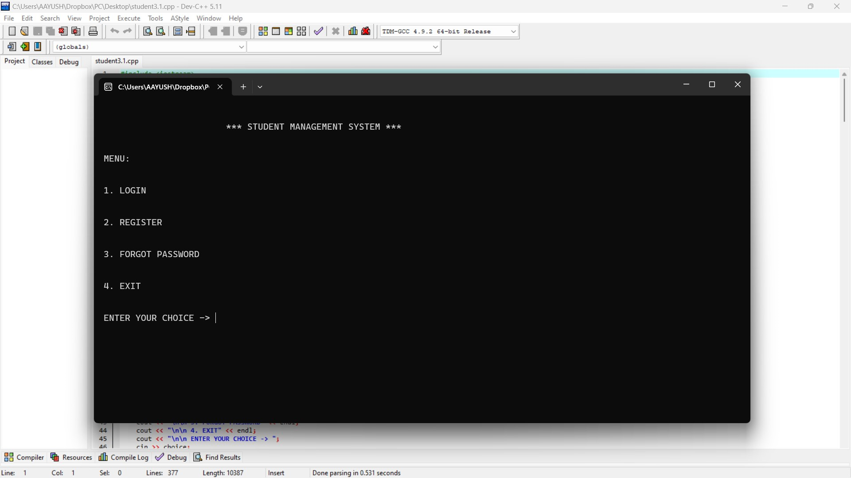

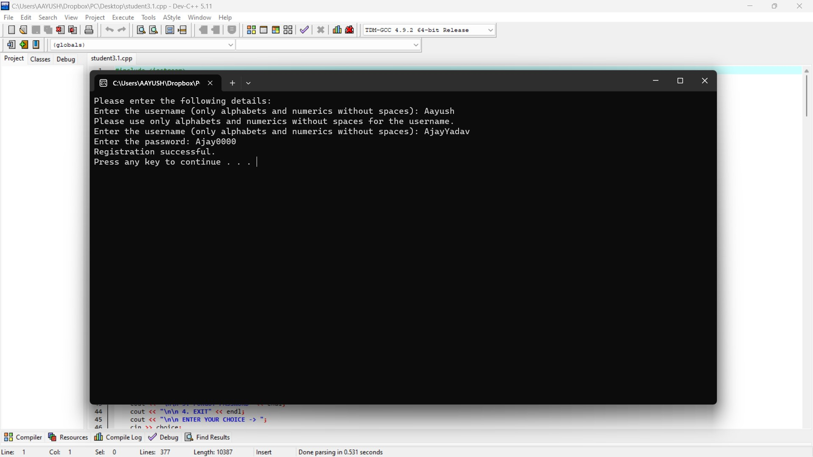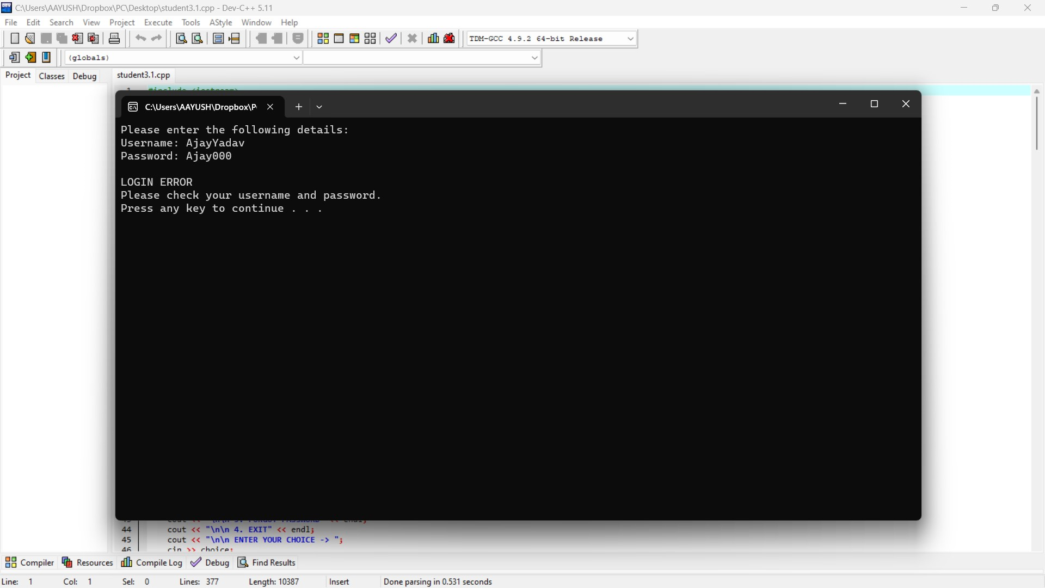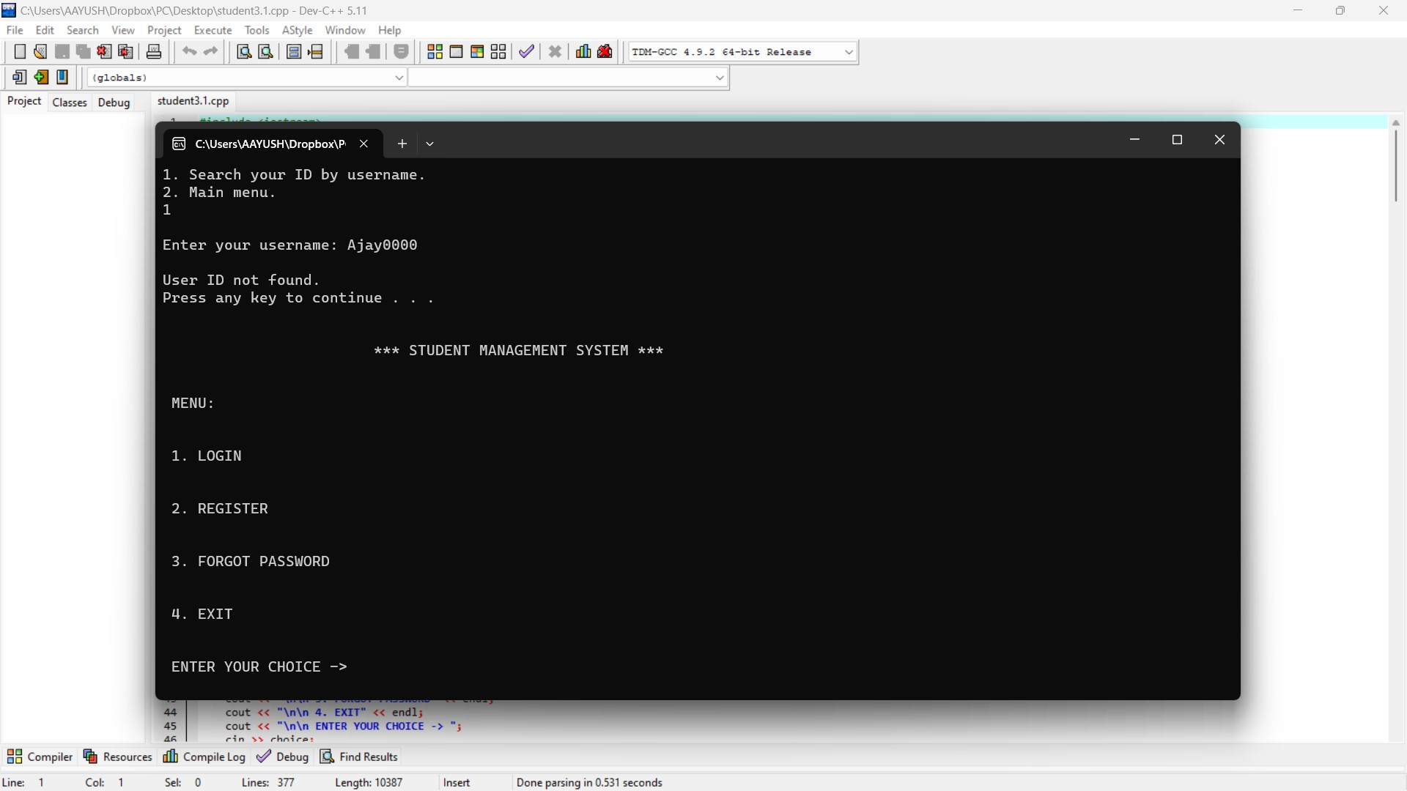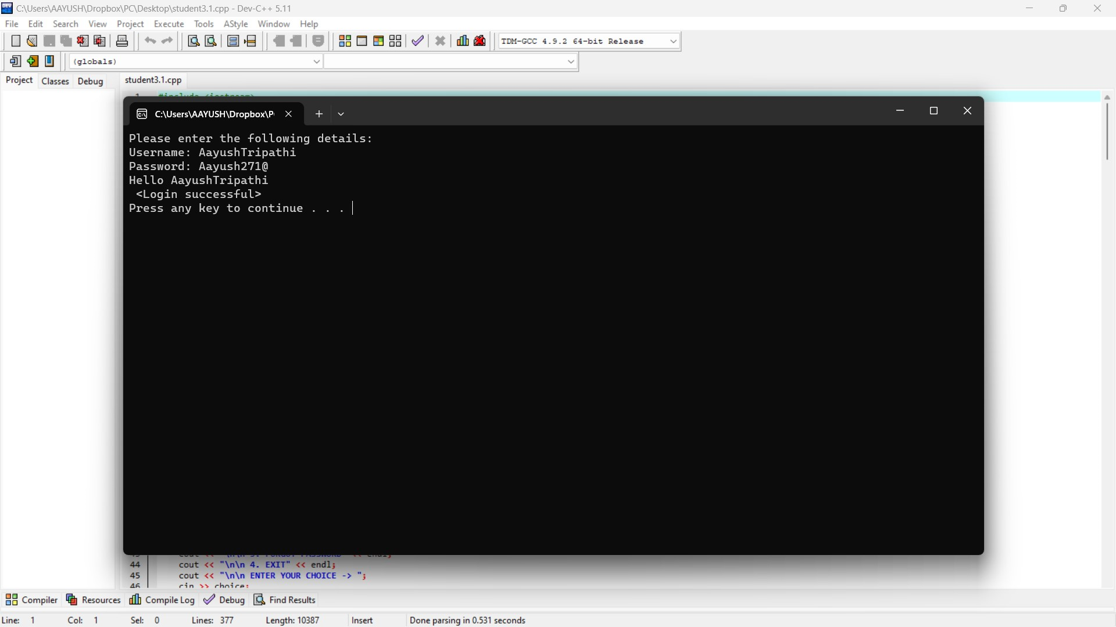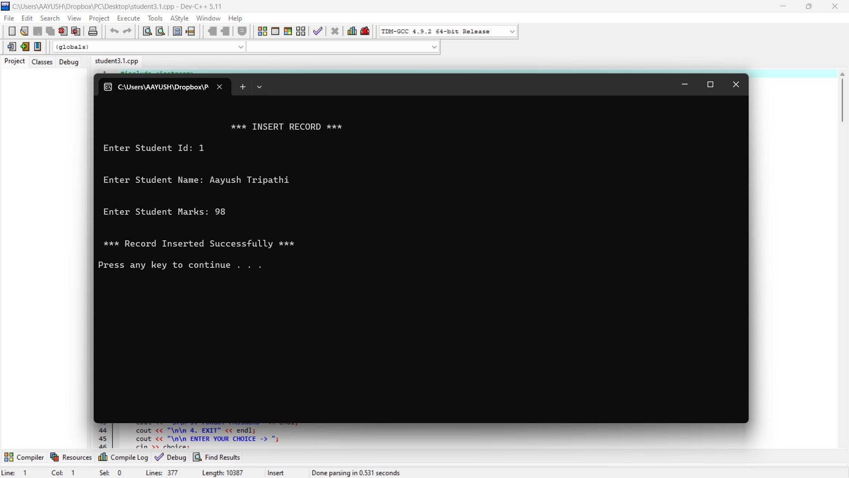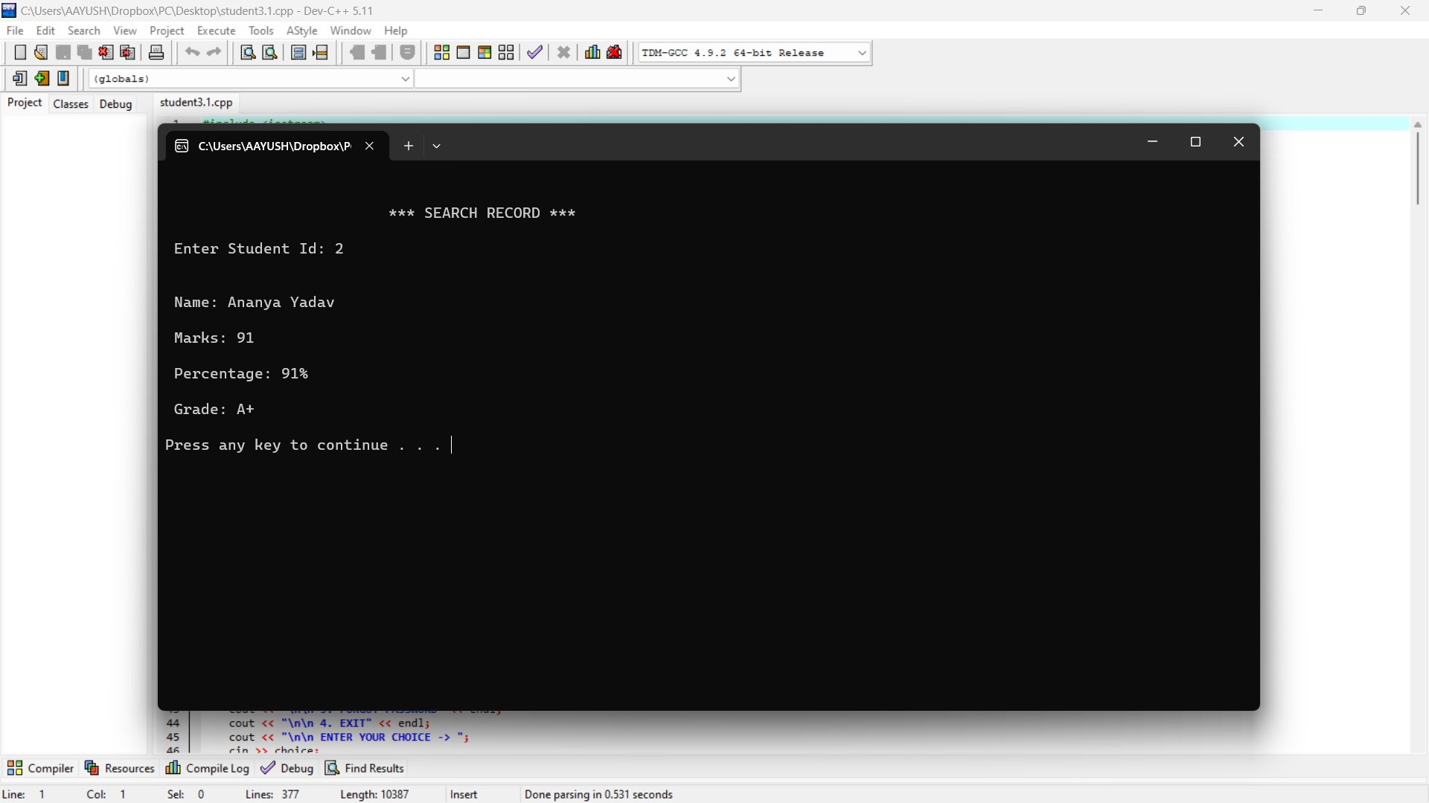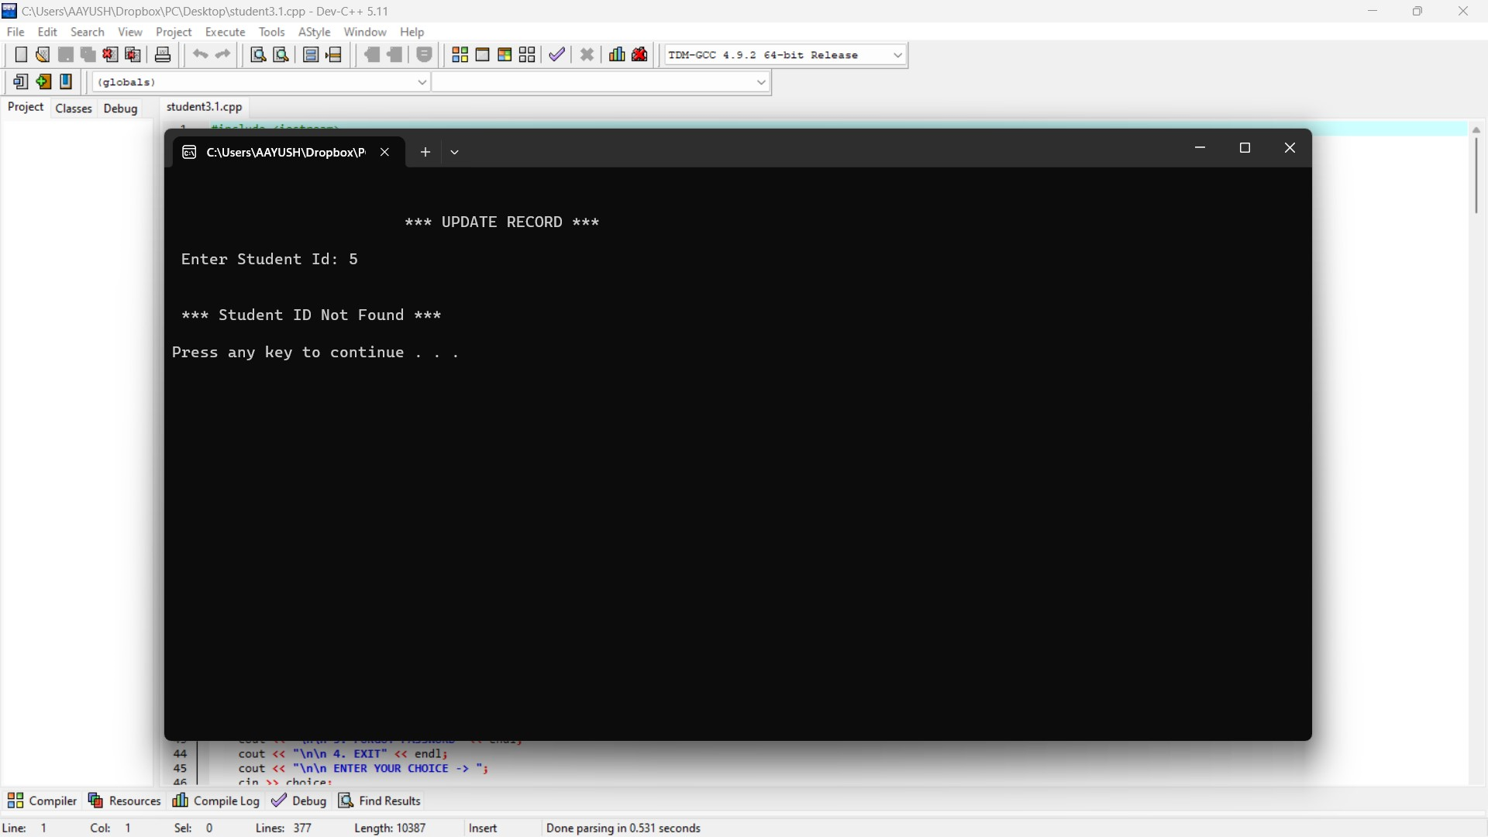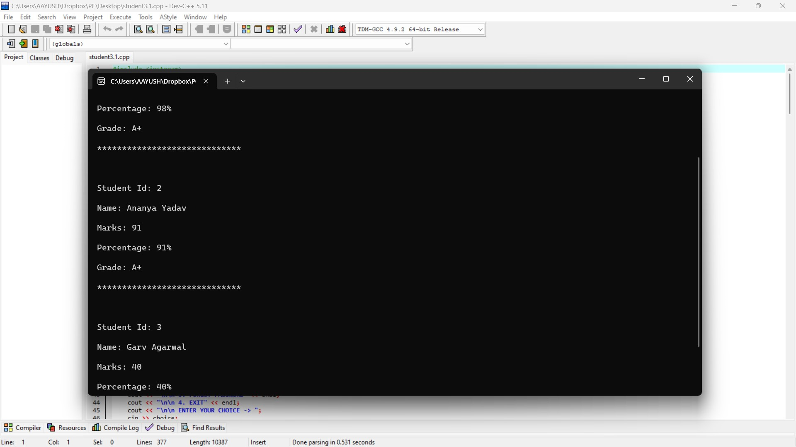

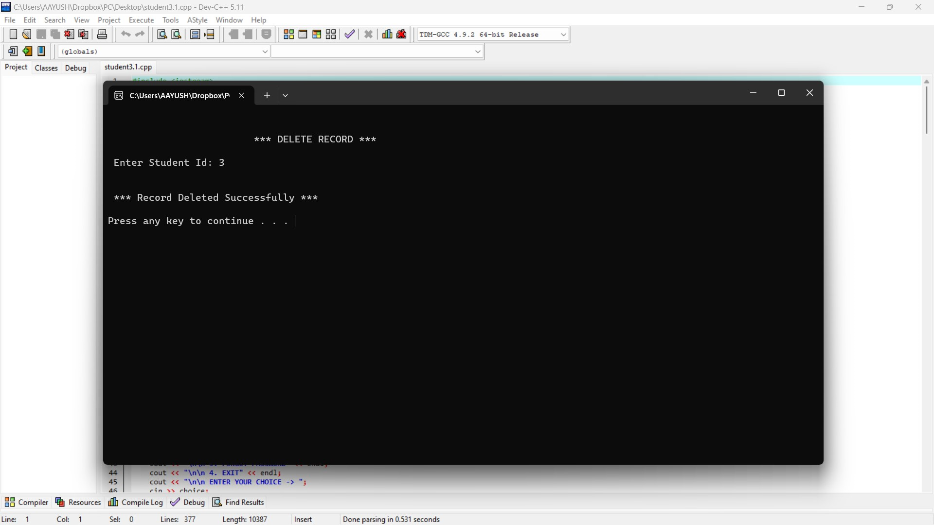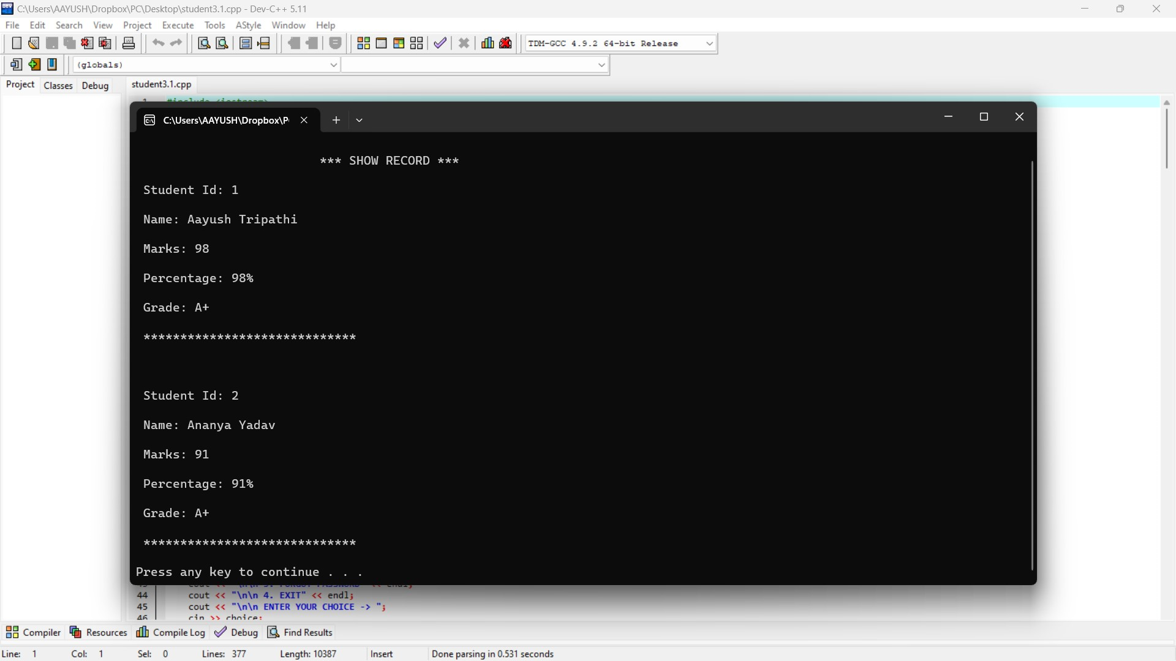

# Conclusion

**Reflecting on the Student Management System Journey**

The journey of conceptualizing, designing, and implementing the Student Management System has been a comprehensive exploration of software development principles, challenges, and opportunities. In this extensive conclusion, we will delve into the project's overarching themes, successes, challenges, lessons learned, and avenues for future growth.

**7.1 Overview of the Student Management System Project**

The Student Management System project emerged as a response to the need for an efficient and secure platform to manage student records. From its inception, the project aimed to streamline the processes of recording, retrieving, and updating student information while ensuring a user-friendly experience. The project's primary functionalities included user authentication, CRUD operations for student records, data persistence through file handling, and a console-based user interface.

Through the careful selection of C++ as the programming language and the utilization of standard libraries such as **<iostream>**, **<fstream>**, and **<string>**, the project laid a foundation for simplicity, clarity, and functionality. The choice of a console-based interface, though basic, provided an accessible means for users to interact with the system.

**7.2 Successes and Achievements**

The Student Management System project achieved several notable successes, affirming its ability to meet the specified requirements and deliver a functional solution. Let's examine these successes in detail:

**7.2.1 User Authentication and Security:** The implementation of user authentication successfully secured the entry point to the system. Users are required to log in with valid credentials, ensuring that only authorized individuals can access and manipulate student records. The project established a foundation for secure user authentication, laying the groundwork for future enhancements.

**7.2.2 CRUD Operations for Student Records:** The core functionality of the system, encompassing CRUD operations, was implemented with efficiency and accuracy. Users could seamlessly create, read, update, and delete student records, providing a comprehensive set of tools for managing student information. The project's success in executing these fundamental operations reflects its commitment to functionality and user empowerment.

**7.2.3 Data Persistence through File Handling:** The incorporation of file handling ensured data persistence between different sessions of the application. User data and student records were stored in separate files (**users.txt** and **students.txt**), contributing to the resilience and longevity of the system. File handling provided a straightforward yet effective mechanism for storing and retrieving data.

**7.2.4 Console-Based User Interface:** While basic, the console-based user interface facilitated user interactions with the system. The menu-driven approach guided users through available options, making the system accessible to a diverse user base. The decision to use console interactions aligned with the project's scope and complexity.

**7.2.5 Choice of Programming Language and Libraries:** The selection of C++ as the programming language and the use of standard libraries demonstrated a thoughtful approach to tooling. C++ provided a balance between performance and development ease, while standard libraries such as **<iostream>**, **<fstream>**, and **<string>** simplified common programming tasks. This choice contributed to code clarity, conciseness, and portability.

**7.3 Challenges Encountered**

The development of the Student Management System project was not without its challenges. Understanding and addressing these challenges were integral to the project's growth and refinement:

**7.3.1 Scalability Limitations:** The project, as initially designed, faced limitations in scalability. The use of an array for maintaining unique student IDs imposed constraints on the number of records the system could handle. Future enhancements could explore more scalable data structures to accommodate a growing number of student records.

**7.3.2 Console-Based Interface Limitations:** While the console-based interface served the project's immediate needs, it had inherent limitations in terms of user experience and visual appeal. Future iterations might consider transitioning to graphical user interfaces (GUIs) to enhance accessibility and appeal to a broader audience.

**7.3.3 Limited Error Handling:** The project lacked extensive error-handling mechanisms, leaving potential vulnerabilities in user inputs, file operations, and other critical areas. Strengthening error-checking and exception handling would contribute to a more robust and resilient system.

**7.4 Lessons Learned**

The development of the Student Management System project was a valuable learning experience, offering insights into software development, project management, and user-centered design. Here are key lessons gleaned from the project:

**7.4.1 Importance of Modular Design:** The project underscored the significance of modular design in software development. Breaking down the system into manageable modules enhanced code organization, readability, and maintainability. Each module served a specific purpose, contributing to the overall functionality of the system.

**7.4.2 Iterative Development Approach:** Adopting an iterative development approach proved beneficial. The project evolved incrementally, with each iteration building upon the successes and lessons learned from the previous phases. This iterative process allowed for flexibility and adaptability to changing requirements.

**7.4.3 User-Centered Design Philosophy:** A user-centered design philosophy guided the development of the project. Prioritizing user authentication, providing a menu-driven interface, and ensuring simplicity in CRUD operations reflected a commitment to meeting user needs. User feedback and usability considerations played a pivotal role in shaping the system.

**7.4.4 Balance Between Performance and Simplicity:** The choice of C++ as the programming language reflected a careful balance between performance and simplicity. C++ provided the efficiency needed for system-level programming while offering a straightforward and standardized approach to common tasks through its standard libraries.

**7.5 Avenues for Future Growth**

The Student Management System project, while achieving its immediate goals, presents numerous opportunities for future growth and enhancements. Exploring these avenues will contribute to the project's evolution and relevance:

**7.5.1 Scalability with Advanced Data Structures:** Addressing scalability limitations could involve transitioning to more advanced data structures, such as hash tables or databases. These structures could efficiently manage larger sets of student records, accommodating the system's growth over time.

**7.5.2 Advanced Authentication Mechanisms:** Enhancing security could involve the implementation of advanced authentication mechanisms. Multi-factor authentication, integration with external authentication providers, or the use of secure protocols could fortify the system against potential security threats.

**7.5.3 Graphical User Interfaces (GUIs):** Introducing graphical user interfaces (GUIs) could significantly enhance the user experience. GUIs offer a visually appealing and intuitive platform for users to interact with the system. Considerations for accessibility and user engagement would drive the design of GUI elements.

**7.5.4 Error-Handling and Resilience:** Strengthening error-handling mechanisms and resilience in the system is paramount. Comprehensive error checking, exception handling, and robust validation of user inputs would contribute to a more dependable and user-friendly application.

**7.5.5 Sorting and Filtering Capabilities:** Integrating sorting and filtering options for student records could empower users with advanced data management capabilities. Users might benefit from the ability to sort records based on various criteria or filter records to retrieve specific subsets of data.

**7.6 Conclusion: Navigating the Software Development Landscape**

In conclusion, the Student Management System project represents a journey through the intricate landscape of software development. From its inception to its current state, the project has demonstrated a commitment to functionality, security, and user-centric design. Successes in implementing user authentication, CRUD operations, data persistence, and a console-based interface validate the project's ability to fulfill its primary objectives.

The challenges encountered during the project's development were valuable learning experiences. They underscored the importance of scalability, user interface considerations, and comprehensive error handling in building robust and resilient software solutions. The lessons learned from these challenges provide insights that will undoubtedly inform future projects and endeavors.

As the project evolves, it stands at the threshold of future growth and innovation. Opportunities to enhance scalability, security, user experience, and system resilience beckon, inviting developers to explore new horizons and embrace the dynamic nature of software development. The identified avenues for future growth serve as guideposts, directing the project toward continued relevance and excellence.

The Student Management System project, in its current form, represents a milestone—a testament to the dedication, creativity, and problem-solving skills of its developers. Its journey does not end here but rather enters a phase of continuous improvement, adaptation, and innovation. The path forward holds the promise of an ever-evolving and impactful solution in the realm of student record management.

**Bibliography**

**1. Stroustrup, B. (2013).** "The C++ Programming Language." Addison-Wesley.

* This seminal work by Bjarne Stroustrup, the creator of C++, provides a comprehensive guide to the C++ programming language. It was instrumental in understanding the nuances and features of C++ used in the project.

**2. Josuttis, N. M. (2012).** "The C++ Standard Library: A Tutorial and Reference (2nd Edition)." Addison-Wesley.

* Nicolai Josuttis' book serves as an authoritative guide to the C++ Standard Library. It played a crucial role in the project by providing insights into using standard libraries such as **<iostream>**, **<fstream>**, and **<string>**.

**3. Gamboa, R. (2017).** "C++ File I/O." GeeksforGeeks. [Link](https://www.geeksforgeeks.org/file-handling-c-classes/)

* This online resource from GeeksforGeeks provided valuable insights into file handling in C++, including the usage of **<fstream>** for reading and writing data to files. It was referenced during the implementation of data persistence in the project.

**4. McConnell, S. (2004).** "Code Complete: A Practical Handbook of Software Construction (2nd Edition)." Microsoft Press.

* Steve McConnell's classic work on software construction covers fundamental principles of software development. While not directly cited, the principles outlined in this book influenced the overall approach to modular design and code organization in the project.

**5. Stack Overflow Community.** [Link](https://stackoverflow.com/)

* The Stack Overflow community served as an invaluable resource for troubleshooting and problem-solving throughout the development process. Numerous code snippets and discussions from this community informed various aspects of the project.

**6. ISO/IEC Standard 14882:2017.** "Programming Languages - C++." International Organization for Standardization (ISO).

* The official ISO/IEC standard document for the C++ programming language was referenced for a deeper understanding of language features and behaviors. It played a role in ensuring compliance with C++ standards.

**7. Gupta, A. (2021).** "Console Input/Output in C++." GeeksforGeeks. [Link](https://www.geeksforgeeks.org/basic-inputoutput-c/)

* GeeksforGeeks provided a concise guide to console input/output in C++, including the usage of **cin** and **cout**. This resource was referenced during the design of the console-based user interface.

**8. Microsoft Docs.** "conio.h." [Link](https://docs.microsoft.com/en-us/cpp/c-runtime-library/reference/conio-h?view=msvc-160)

* The Microsoft Docs resource on **conio.h** was consulted for understanding the usage of this header file for console input and output management. While acknowledged, it's important to note that the use of **conio.h** is platform-dependent.

**9. Schildt, H. (2013).** "C++: The Complete Reference (4th Edition)." McGraw-Hill Education.

* Herbert Schildt's comprehensive reference on C++ provided additional insights into language features and programming techniques. While not directly cited, it served as a supplementary resource during the project.

**10. Hunt, A., & Thomas, D. (2000).** "The Pragmatic Programmer: Your Journey to Mastery." Addison-Wesley.

**11. Gang of Four (Erich Gamma, Richard Helm, Ralph Johnson, John Vlissides). (1994).** "Design Patterns: Elements of Reusable Object-Oriented Software." Addison-Wesley.

**12. GNU Project.** [Link](https://gcc.gnu.org/)

13. Various Youtube Channels